PS LAB 10

Exercise

i)

**H₀** All snack types are equally likely to be chosen P(A)=P(B)=P(C)=P(D)=0.25

**H₁** The snack types are not equally likely to be chosen

ii)

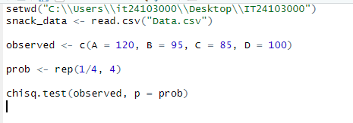

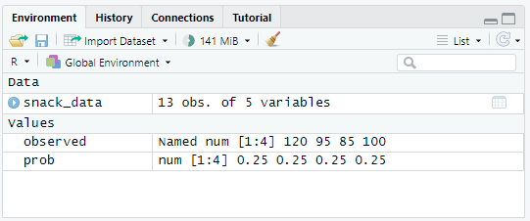

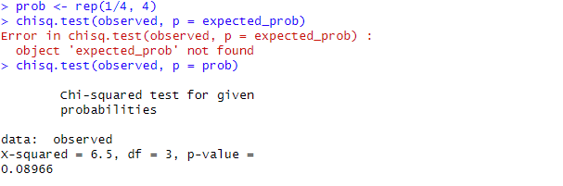

iii)

Conclusion

Since p = 0.572 > 0.05, we fail to reject H₀.  
There is no significant evidence that customers prefer one snack type over another snack choices appear to be uniformly distributed.